**USER MANUAL**

**CS5551 ASE – Project – Speech/Pronunciation Helper**

**Team Members**

**Geetalakshmi Javvadi**

**Jinal Patel**

**Supraja Raghavan**

**Table of Contents:**

Introduction Page 3

Web Services Page 4

The UI - HTML interface Page 5

The Android Interface Page 5

Error and Bugs/Deficiencies Page 5

Application usage Screen shots - Web Browser Page 6

Application usage Screen shots - Android Interface Page 11

**Introduction:**

Globalization has made it possible for people from different parts of the world to interact amongst each other. English is the international language for cross culture communication. English is the most common language. Most of the universities around the world offer courses only in English. Good job opportunities require fluent English accent. Every ethnic group is influenced by the accent of their native language and it becomes difficult to change the accent when they speak in English. Since the people who speak other languages are influenced by the stress on syllables according to their native language it impacts their accent in English. Speech recognition and accent or pronunciation correction is the main idea of our project.

The Speech/Pronunciation Helper Android Application plays a significant role in the correction of accent for non-native speakers in English. People from different native languages face problems in communication as accent of their native language always dominates the pronunciation of their secondary language. This has motivated us in taking up this project which would assist non-native speakers in achieving their language goals efficiently. Our objective is to facilitate the non-native speakers of the English Language to change their accent in speaking certain English words. This would help improve their pronunciation and would enhance their communication.

Our Application has the following features:

* Functional:
  + System allows the user to register.
  + User can log in into the system.
  + User is allowed to choose the group.
  + System will show the list of words and the accent that is followed.
  + User can practice as many times as wanted.
* Non functional:
  + System is easy to use if the user has a login Id.
  + Software tool will be available and accessible almost all the time.
  + The administrator of the system is allowed to add more details to the existing tool to make more tutorials accessible for the user. The software is scalable and can be extended as required.
  + The software tool is usable only by authenticated users; unauthenticated people cannot login into the system to use the tool.

**Significance:**

The significant part of this tool is the accent correction which would enable the proper pronunciation of words and thereby makes the user more confident and comfortable while presenting their ideas and would also favor the listener in understanding the language easily. One of the fascinating aspects of this tool is that it can be used by people of all ages, without any assistance from anyone as it is very simple to operate. It is simple open source software that is readily available to use.

**The Speech/Pronunciation Application:**

This application is accessible through the Web interface and Android Mobile Interface. The user must be an authenticated user to Login to the system, if not the user must first Register to use the application. The user needs to Register to the system and then Login to the application using a valid username and password.

This application allows the user to select various groups based on their ethnicity. The groups contain word list that the users from a particular ethnicity have trouble pronouncing or speaking. The users can then select the required group and listen to the correct accent of the words and practice the correct accent.

**Access to the application:**

The user can access the application, either by using a web browser or by using an android smart phone. The application is suitable only for Android mobile interface.

**Web Services:**

The application uses 3 main web services, namely the Registration, the Login and the Group Selection web services. The details of which are explained below.

**Registration:**

 In this web service the user registers for access to the accent mobile application. They provide the required details such as the:

* + - Username,
    - Password,
    - Name and
    - Email address.

The users are thus registered to the system after which they can login to the system.

**Login:**

After a user has registered for access to the mobile application, the user is authenticated and verified. If the user enters an authentic username and password he is allowed access to the application. The user needs to Login to the application in order to access their group and the word list for their accent group

**Group Selection:**

The web service that we created is used to allow the user to select his/her desired group. The users of our application need to specify a group to which he/she would have access to. The users can select from various groups such as

* Chinese,
* Japanese and
* Indian.

After a user has registered and logged in to the mobile application, the user can access his/her group. This group contains the list of words for which the user would like to learn the accent for. When the user selects a word, the accent audio of the word can be played as many times as the user wants. Thus the user can listen to the words as many times as wanted to practice the correct accent of the word.

**Errors:**

The possible error that a user can encounter would be username and password mismatch, in which case they could contact the admin or register with a different details.

If there is a Service Error or an error message about the availability of the service, the user can mail or contact the admin.

If the user has an error in downloading and running the android application, he can re-download the app because it is a free open source application.

**Bugs/Deficiencies:**

No known bugs or deficiencies exist as of this version. Please do contact the admin if you encounter any bugs or difficulties.

**The detailed step by step guide to using the application through the web browser and the android interface are as shown below.**

**Web Browser:**

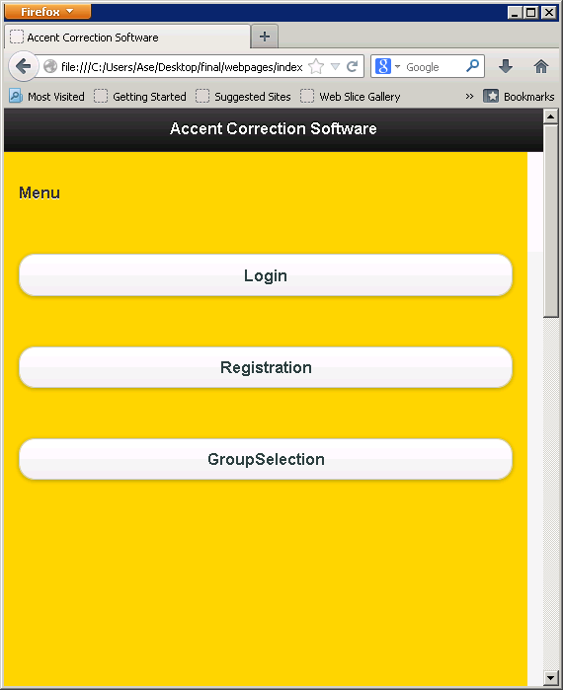**Home Page: User needs to register to login to the application:**

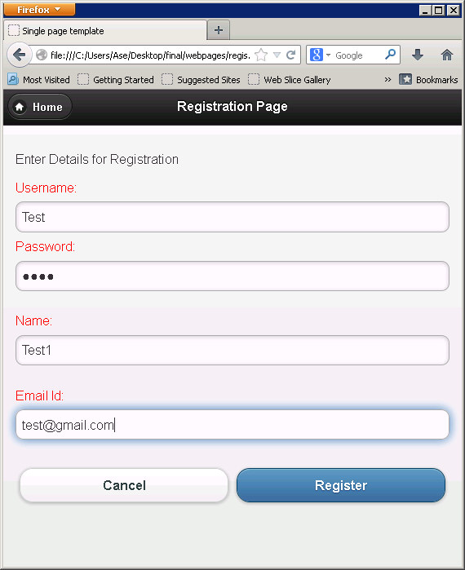**Registration:**

**Login:**

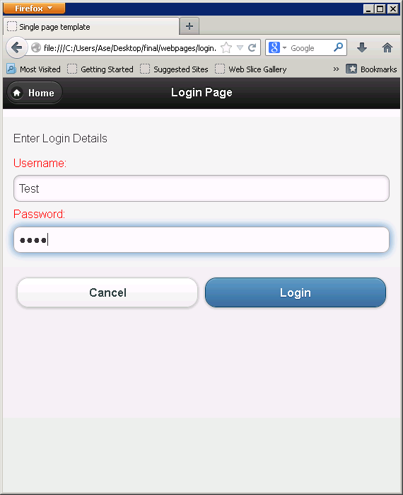

**Group Selection:**

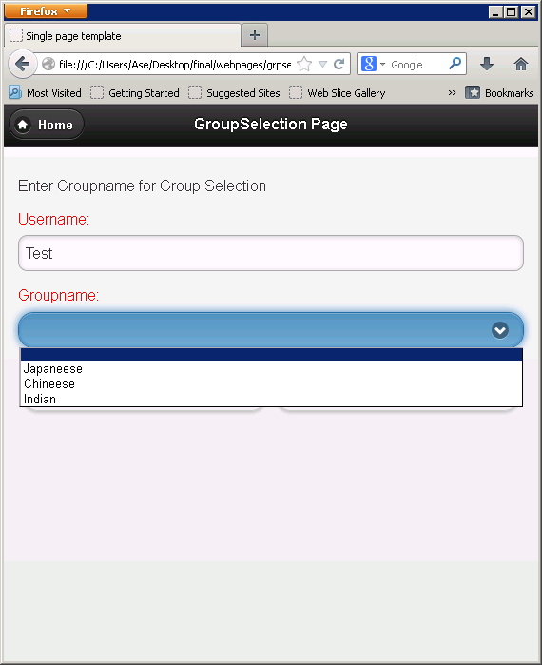

**Word List:**

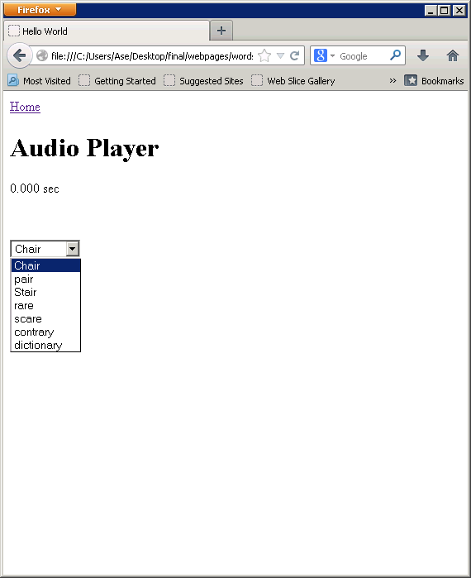

**Android Application Screen shots:**

**Home Page:**

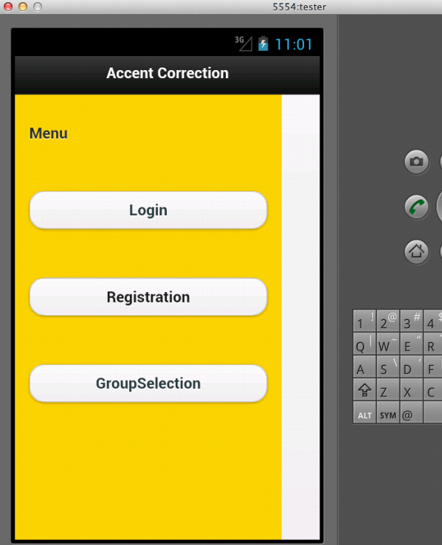

**Registration:**

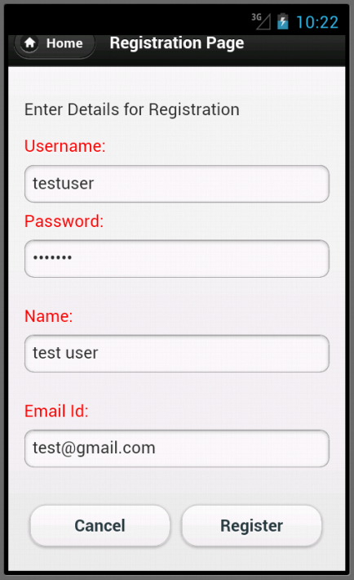

**Login:**

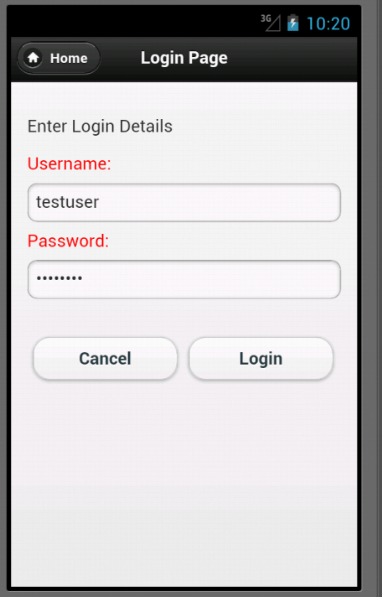

**Group Selection:**

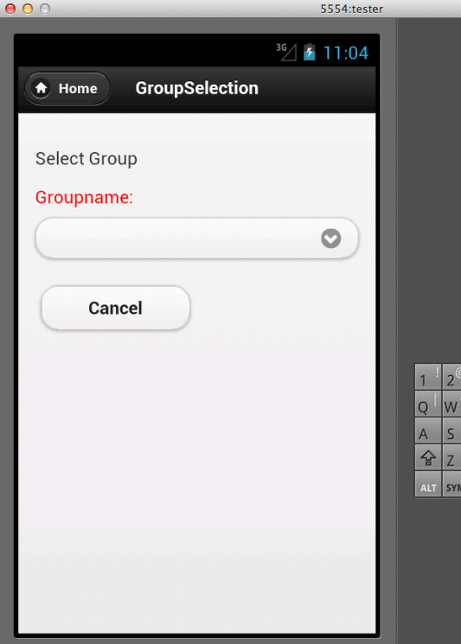

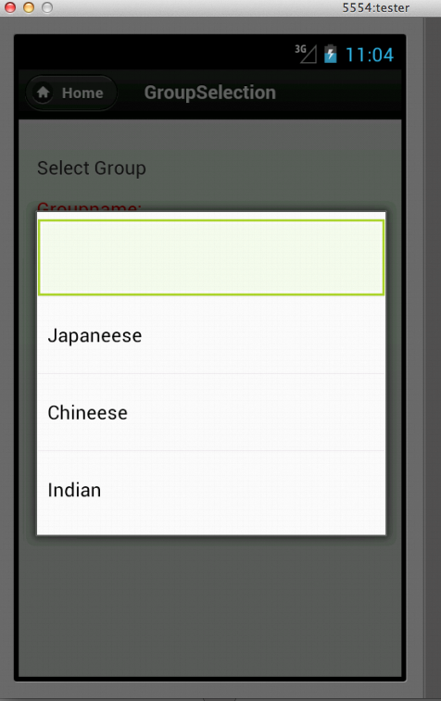

**Word List:**

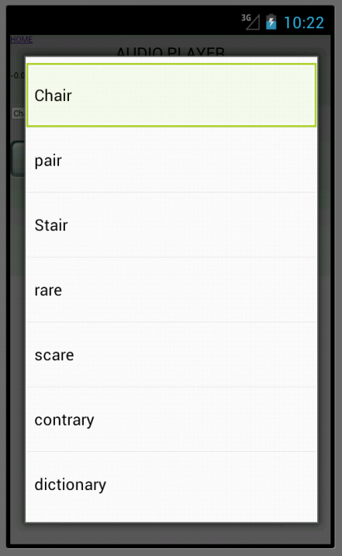

**The user can thus follow these screenshots one by and gain access to our application.**